Can Due 殘雪, penname of Deng Xiaohua 鄧小華 (1953 –)
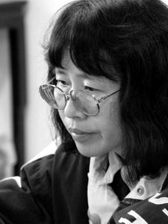
One of China’s most experimental novelists of the post-Mao era, Can Xue has also been one of the most polarizing. While some critics, including the late Susan Sontag, were mesmerized by her surrealist and absurdist tales, others have dismissed her fiction as “hysterical” and “unreadable.” Literally translated as “Leftover Snow Refusing to Melt,” Can Xue’s penname bespeaks the defiance with which she has answered her critics: “If a reader feels that this book is unreadable,” she said in an interview following the publication of a translation of her novel Five Spice Street (2009), “then it’s clear that he is not one of my readers.” (http://www.pri.org/theworld/?q=node/26132). Resisting compartmentalization as a feminist writer or interpretations of her often nightmarish tales as straightforward literary responses to the violence and political excesses of the Mao period, Can Xue imperatively denied that her work is rooted in China’s socio-historic condition. “There is no political cause in my work,” she said in an interview in 2002, maintaining instead that hers is a “literature of the soul” and that its main interest lies in the metaphysical aspect of individual existence. (http://mclc.osu.edu/rc/pubs/mccandlish.htm)

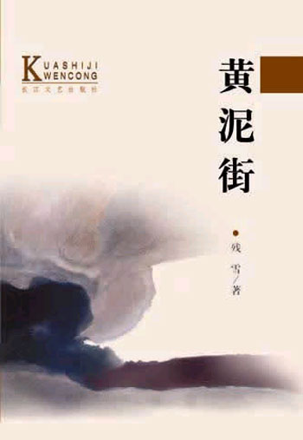
Even though Can Xue does not want her work to be viewed as social commentary, it is hard to imagine that external realities have not had an impact on her literary imagination. Born into a family of intellectuals, Can Xue witnessed how her parents fell victim to various political campaigns aimed at exposing alleged “counter-revolutionaries” during the first decades of the People’s Republic of China. These arbitrary and at times extremely violent events, which culminated in the Cultural Revolution (1966-1976), often defied rational explanation and lent themselves to absurdist artistic responses. In “Hut on the Mountain” (山上的小屋, 1985), one of Can Xue’s first published short stories, a surrealist nightmare unfolds in which the un-gendered narrator becomes increasingly alienated from his or her family and surroundings. In the novella “Yellow Mud Street” (1987), the nightmares of an entire community living among garbage and excrement unfolds as a mysterious entity of indefinable origin comes to haunt everyone’s lives. Retroactively deemed “anti-government,” the work was banned by authorities in 2001, along with Can Xue’s autobiographical essay “A Summer Day in the Beautiful South,” a tribute to her grandmother who died from malnourishment during China’s great famine.
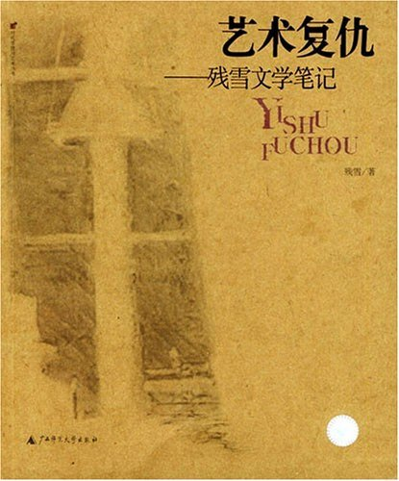

Most of Can Xue’s fiction defies temporal and spatial orientation and explores alienation, solitude, anxiety and at times the comfort and warmth found in interpersonal relations through dreams, hallucinations, or other subjective experiences. This lends her oeuvre the universality that may also be found in the works of other 20th century modernists who experimented with dreamscapes, such as Franz Kafka or Jorge Luis Borges, two writers Can Xue names as important influences on her work. Other writers who exerted influence on her were Italo Calvino, Goethe, Shakespeare or Dante, all of whom she discussed in a number of collections of literary criticism such as her Revenge Through Art: Can Xue’s Notes on Literature (2003).
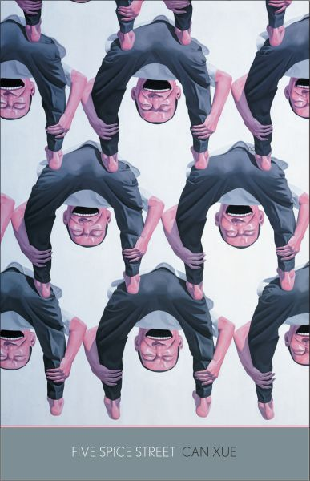
Search for identity and exploration of self characterize much of Can Xue’s fiction. In Five Spice Street (2002), her fist full-length novel, an entire neighborhood becomes obsessed with the secrets surrounding a mysterious Madam X, her husband and son, as well as her lover Mr. Q. Grotesque interpersonal relations are another recurring theme in in Can Xue’s oeuvre. In “My Brother” (弟弟, 1997), the narrator travels to the Western deserts of China to reconnect with a lost bother, and in “Mother Rat” (2003), the narrator comes to live in the house of his brother, where he becomes obsessed with a rat while growing alienated from his family. Can Xue’s fiction rarely offers narrative closure. It probes into ever new levels of absurdity of human existence, suggesting that the only meaning that is possible in life is a permanent expansion of metaphysical spheres. Subjective experience in Can Xue’s fiction becomes the only authentic and accessible truth. Only such writing, Can Xue claims, “can truly create something new, and evoke a response from the depth of human emotions.”

Selected Bibliography:

Studies of Can Xue:

Cai, Rong (2004) The Subject in Crisis in Contemporary Chinese Literature, Honolulu: University of Hawai’i Press. (Contains chapter on Can Xue in which author draws on Jean-Paul Satre to read existentialist anxiety in Can Xue’s fiction as a commentary on life in post-revolutionary China)

Lu, Tonglin (1995) Misogyny, Cultural Nihilism, and Oppositional Politics: Contemporary Chinese Experimental Politics, Stanford: Stanford University Press. (Contains chapter on Can Xue that illustrates how her experimental fiction mocks masculine monopolization and misogynism of literary language in China)

Works in English Translation:

DIALOGUES IN PARADISE (1989) (Contains “A Summer Day in the Beautiful South” and “Hut on the Mountain”)

OLD FLOATING CLOUD (1991) (Contains “Yellow Mud Street”)

The Embroidered Shoes (1997)

BLUE LIGHT IN THE SKY (2006) (Contains “My Brother”)

FIVE SPICE STREET (2009)

Short Stories & Novels:

YELLOW MUD STREET (黃泥街, 1987)

Dialogues in Paradise (天堂裡的對話, 1988)

“MY BROTHER” (弟弟, 1997)

FIVE SPICE STREET (五香街, 2002)

“MOTHER RAT” (母鼠, 2003)

A Never-Described Dreamscape: The Complete Short Stories of Can Xue (從未描述過的夢境: 殘雪短片小說全集, 2004)

Miss Lü Fangshi (呂芳詩小姐, 2011)

Essays & Critcisim:

REVENGE THROUGH ART: CAN XUE’S NOTES ON LITERATURE (藝術復仇: 參學文學筆記, 2003)

Interviews & Resources Online:

“Stubbornly Illuminating ‘the Dirty Snow that Refuses to Melt’: A Conversation with Can Xue.” MCLC Resources Center, 2002.
http://mclc.osu.edu/rc/pubs/mccandlish.htm

“Modern Mystery Street." Interview by Bill Marx. PRI's The World. PRI, 14 Apr. 2009.
http://www.pri.org/theworld/?q=node/26132

“Can Xue.” MIT’s Contemporary Chinese Writers Website Project. Includes video footage of Can Xue.
http://web.mit.edu/ccw/can-xue/

